CN Lab Report – Week 9

PES1201800366

Aditeya Baral

**1. IPv6 Address and Topology Creation**

* The following topology was created and deployed on **ClayNet**.
* The two workstations are labelled as Alice and Bob for this experiment.

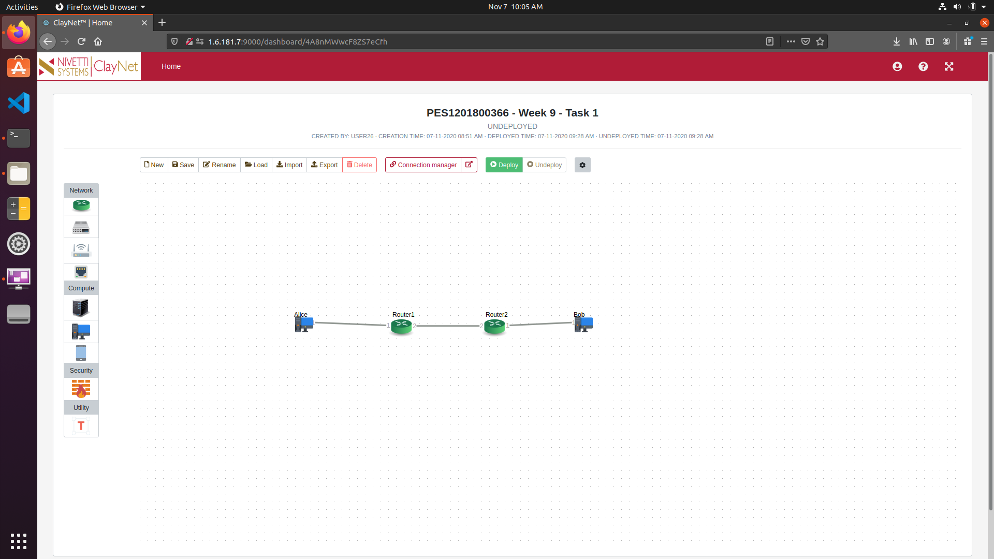

* The end-systems are configured initially as follows

|  |  |  |
| --- | --- | --- |
| **End System Name** | **IP Address** | **Gateway** |
| Alice | 2001::02/24 | 2001::02 |
| Bob | 2003::02/24 | 2003::01 |

**2. Router Configuration**

* IPv6 Addresses must be set for each router using the console.
* We first enable the IPv6 mode in both routers.

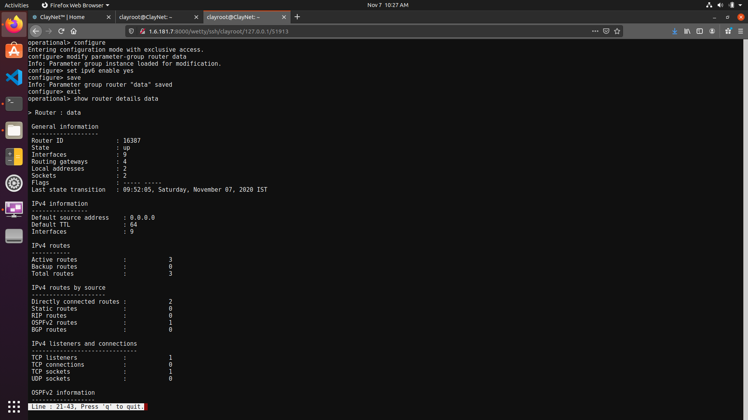

**2.1 Router 1**

* Router 1 is configured by assigning the IPv6 Address 2001::01/64 to the if-port-1 interface as shown below.

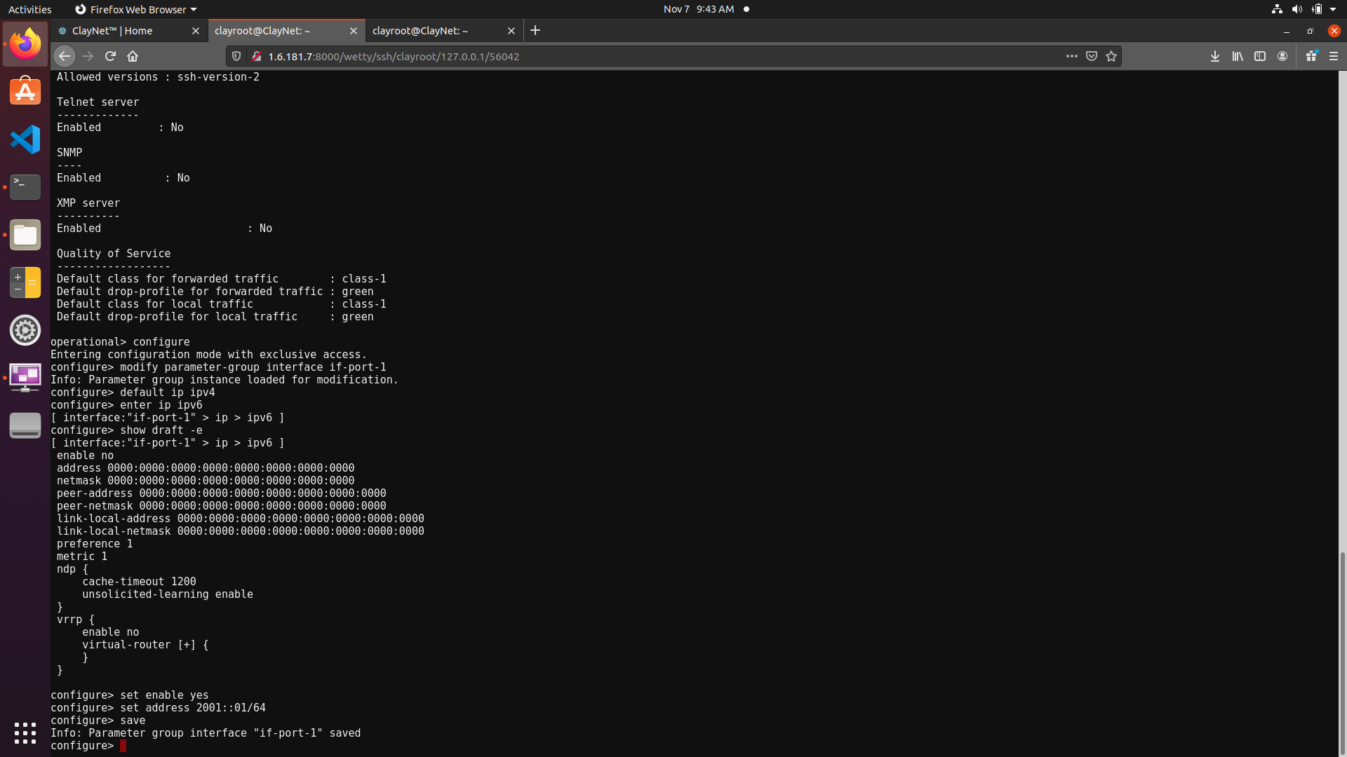

* Similarly, the IPv6 Address of 2002::01/64 is set for the if-port-2 interface as shown below.

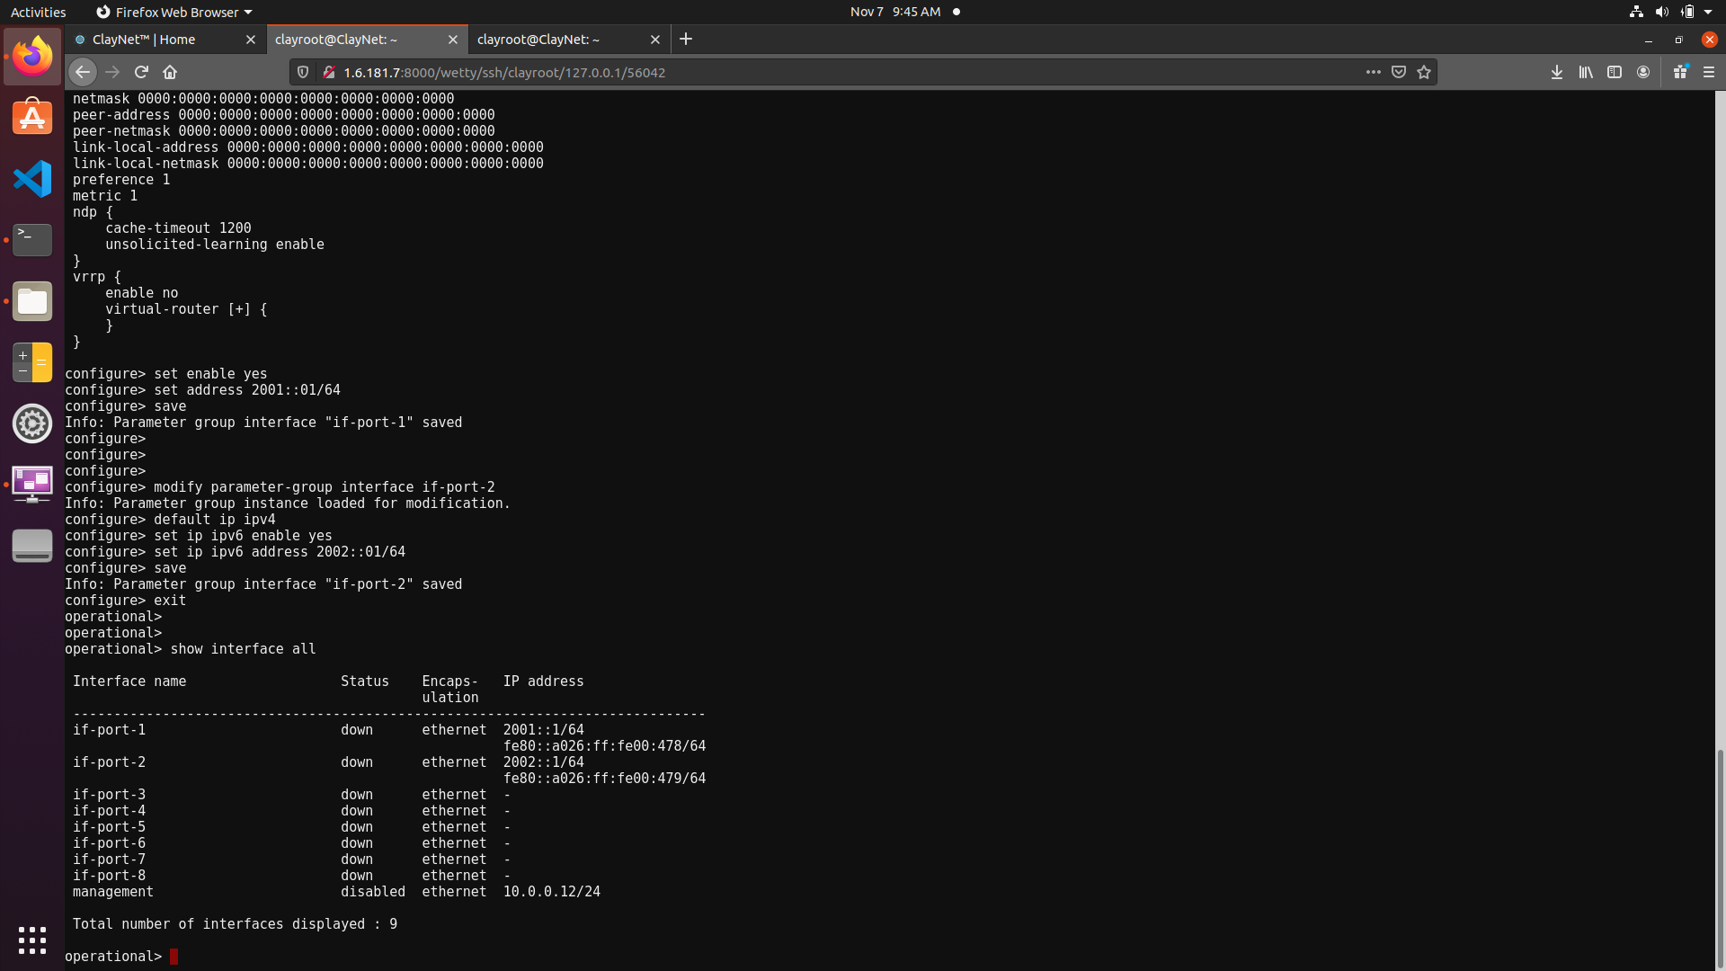

* The full interface configuration for Router 1 is shown below.

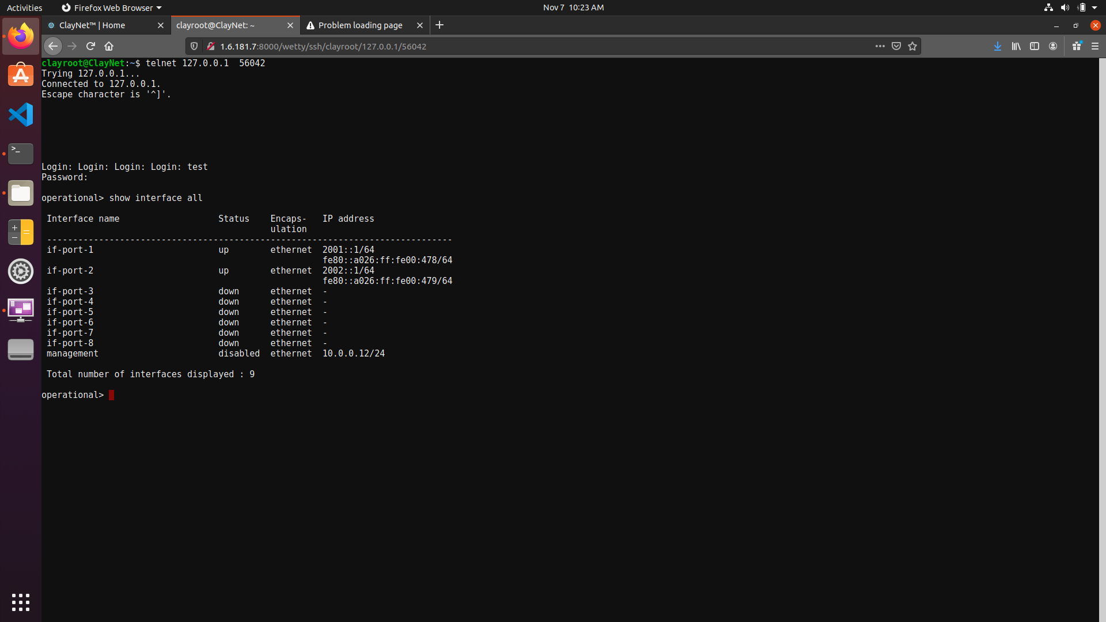

* The routing table entries are now configured. After configuration, the routing table for Router1 can be seen below.

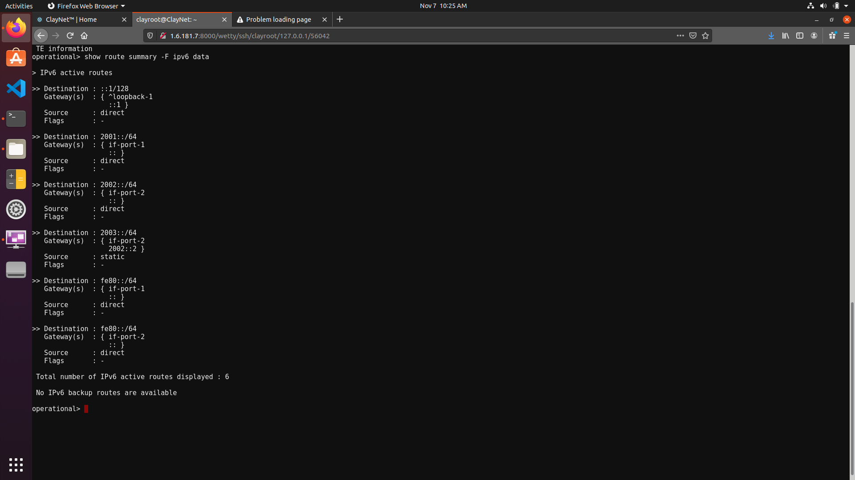

**2.2 Router 2**

* The IPv6 Addresses for the interfaces if-port-1 and if-port-2 are set similarly.

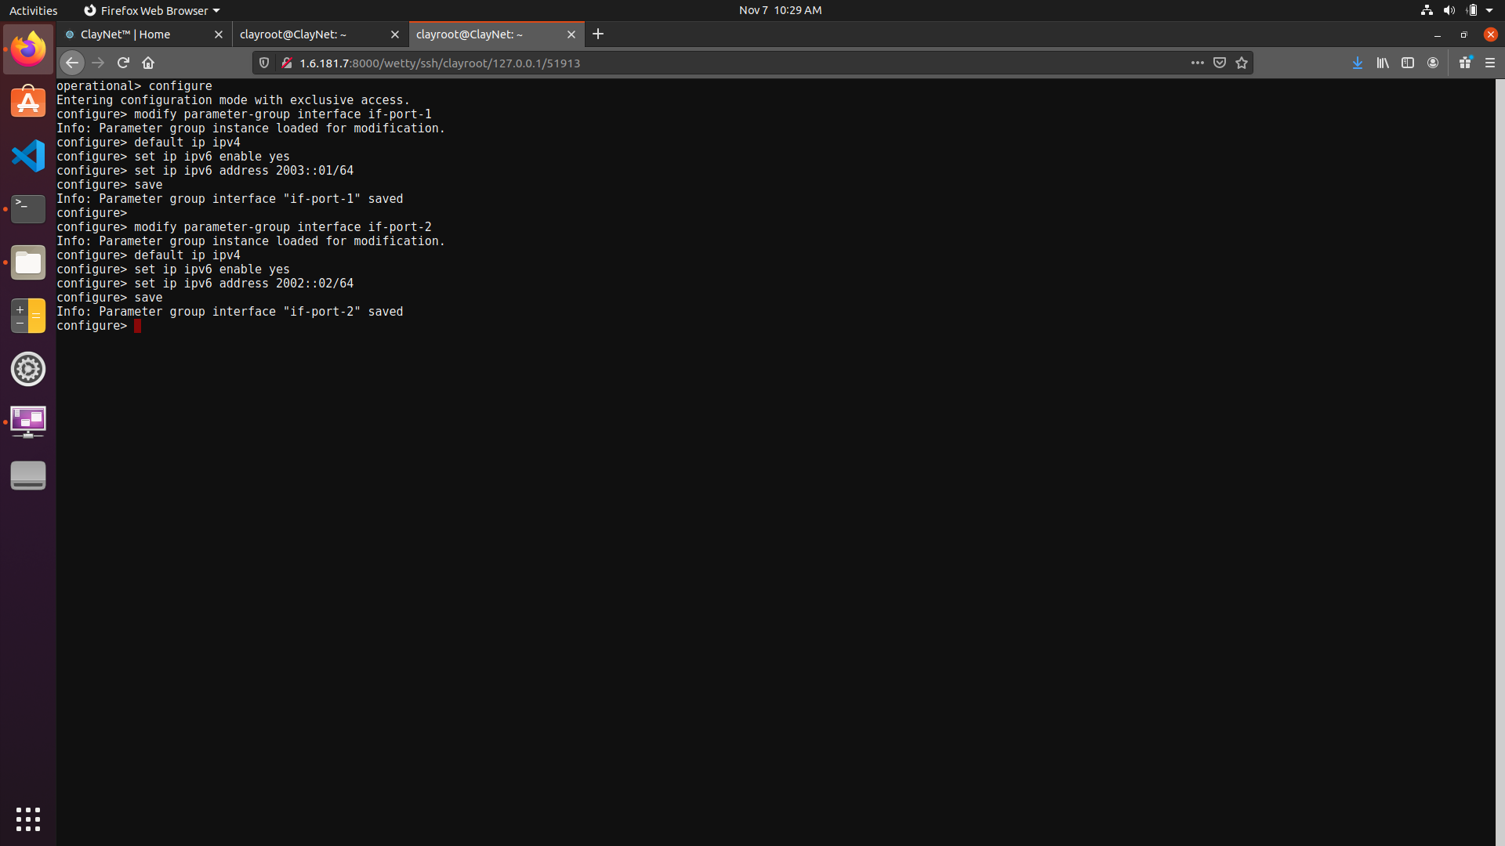

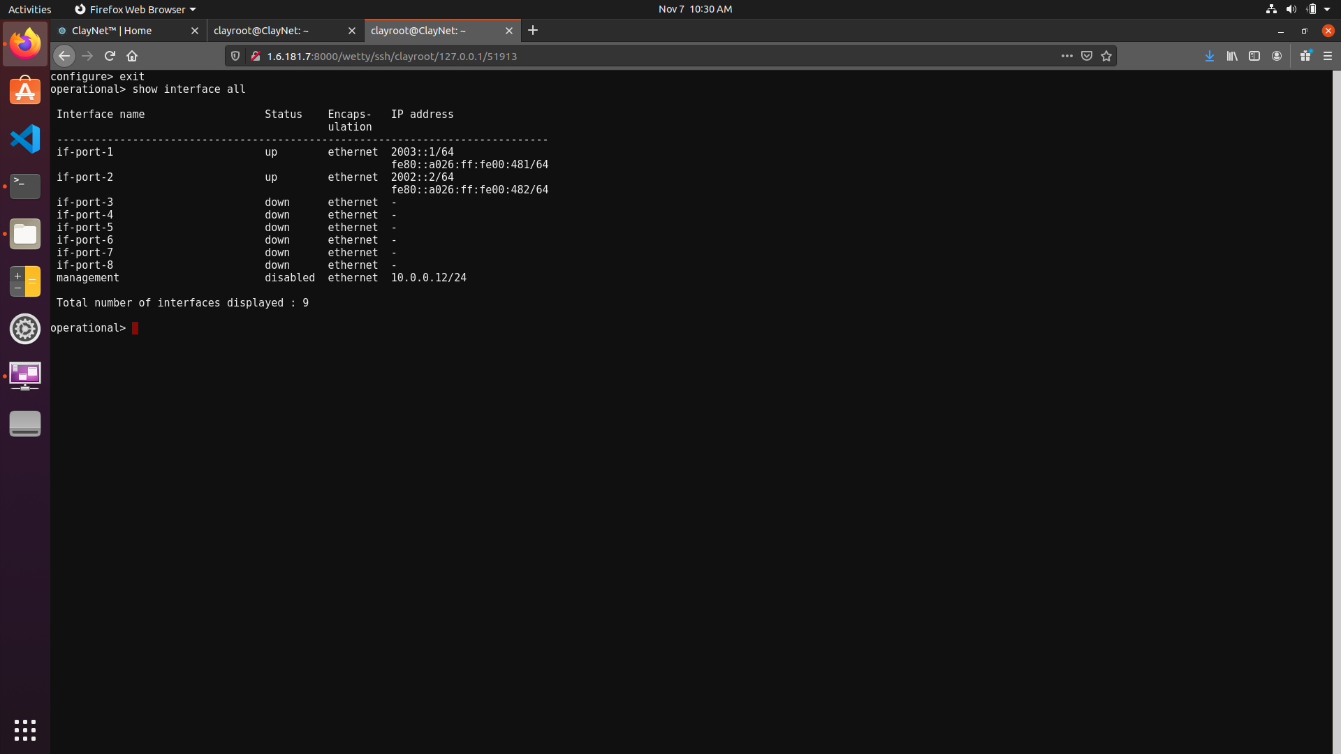

* The routing table entries are configured as well and are shown below.

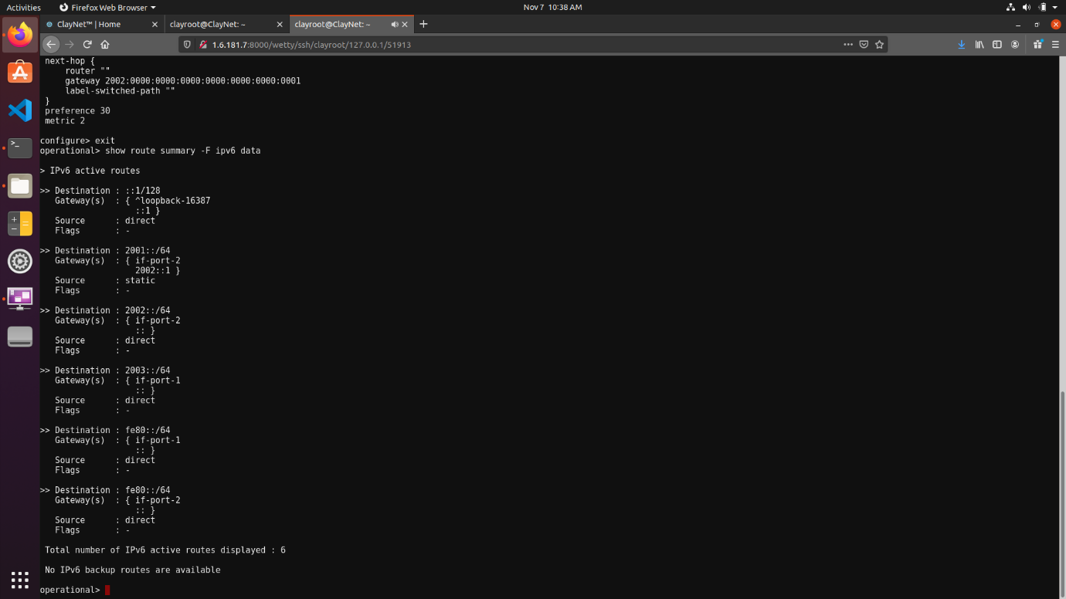

**3. Observations**

**3.1 Ping Command**

* Successful ping requests can be sent from Alice to Bob workstations as shown below.
* Since there are 2 hops between the workstations, the TTL value is reduced by 2 from its default value of 64 to 62.

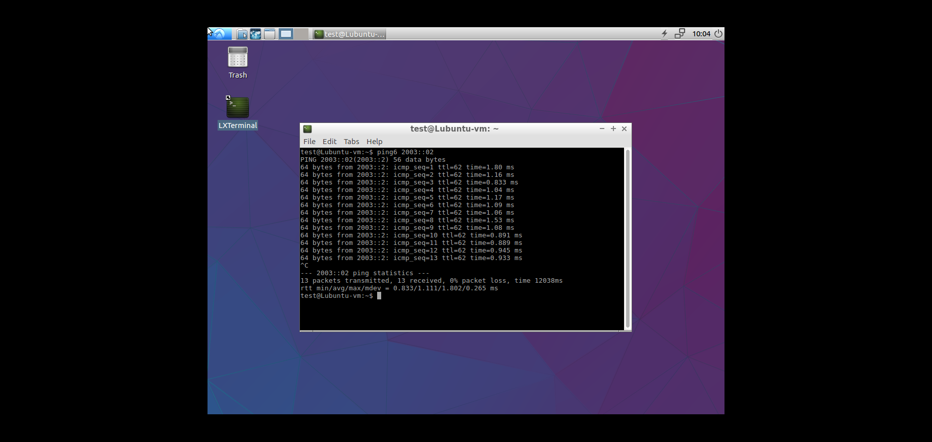

**3.2 Tracepath Command**

* A similar tracepath command can be issues from Alice to Bob as shown below.

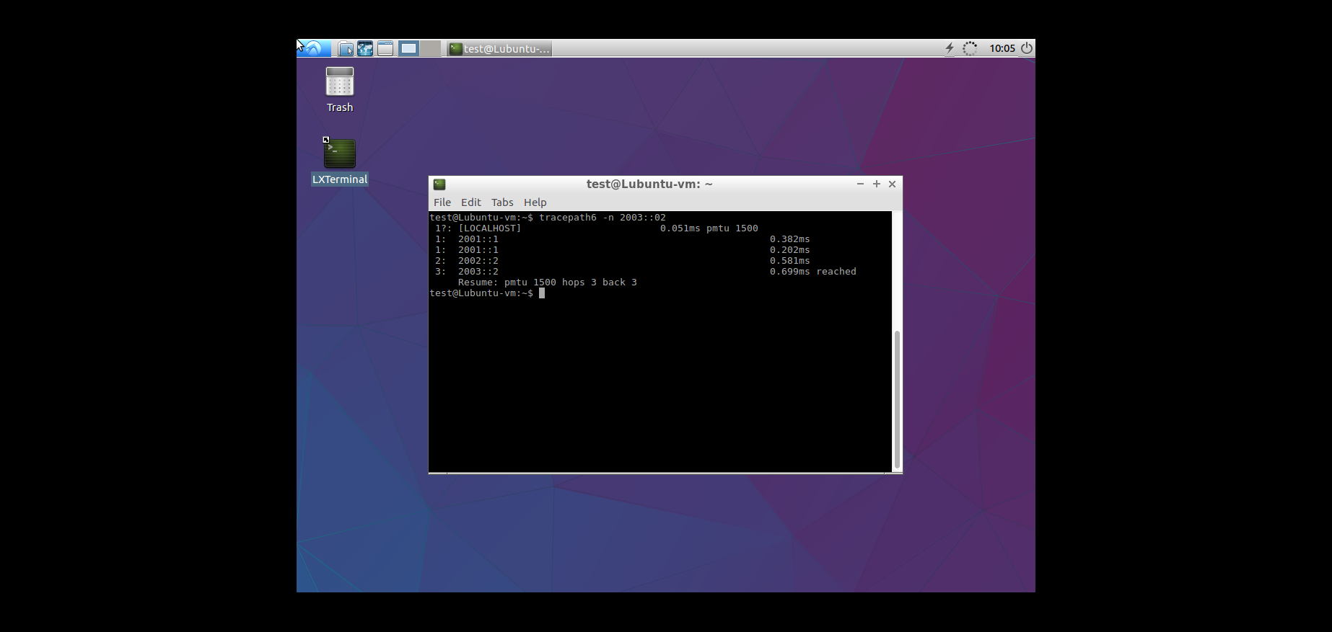

**3.3 Neighbour Table**

* We can view the neighbour table for Router1 using the following command.

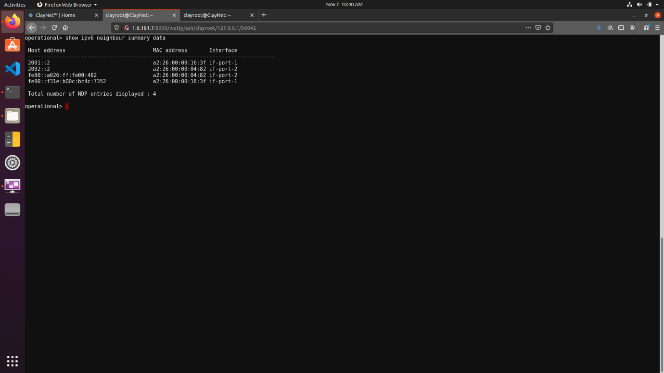

* We can also obtain the link-local address of interface if-port-2 on Router2 using the following command.

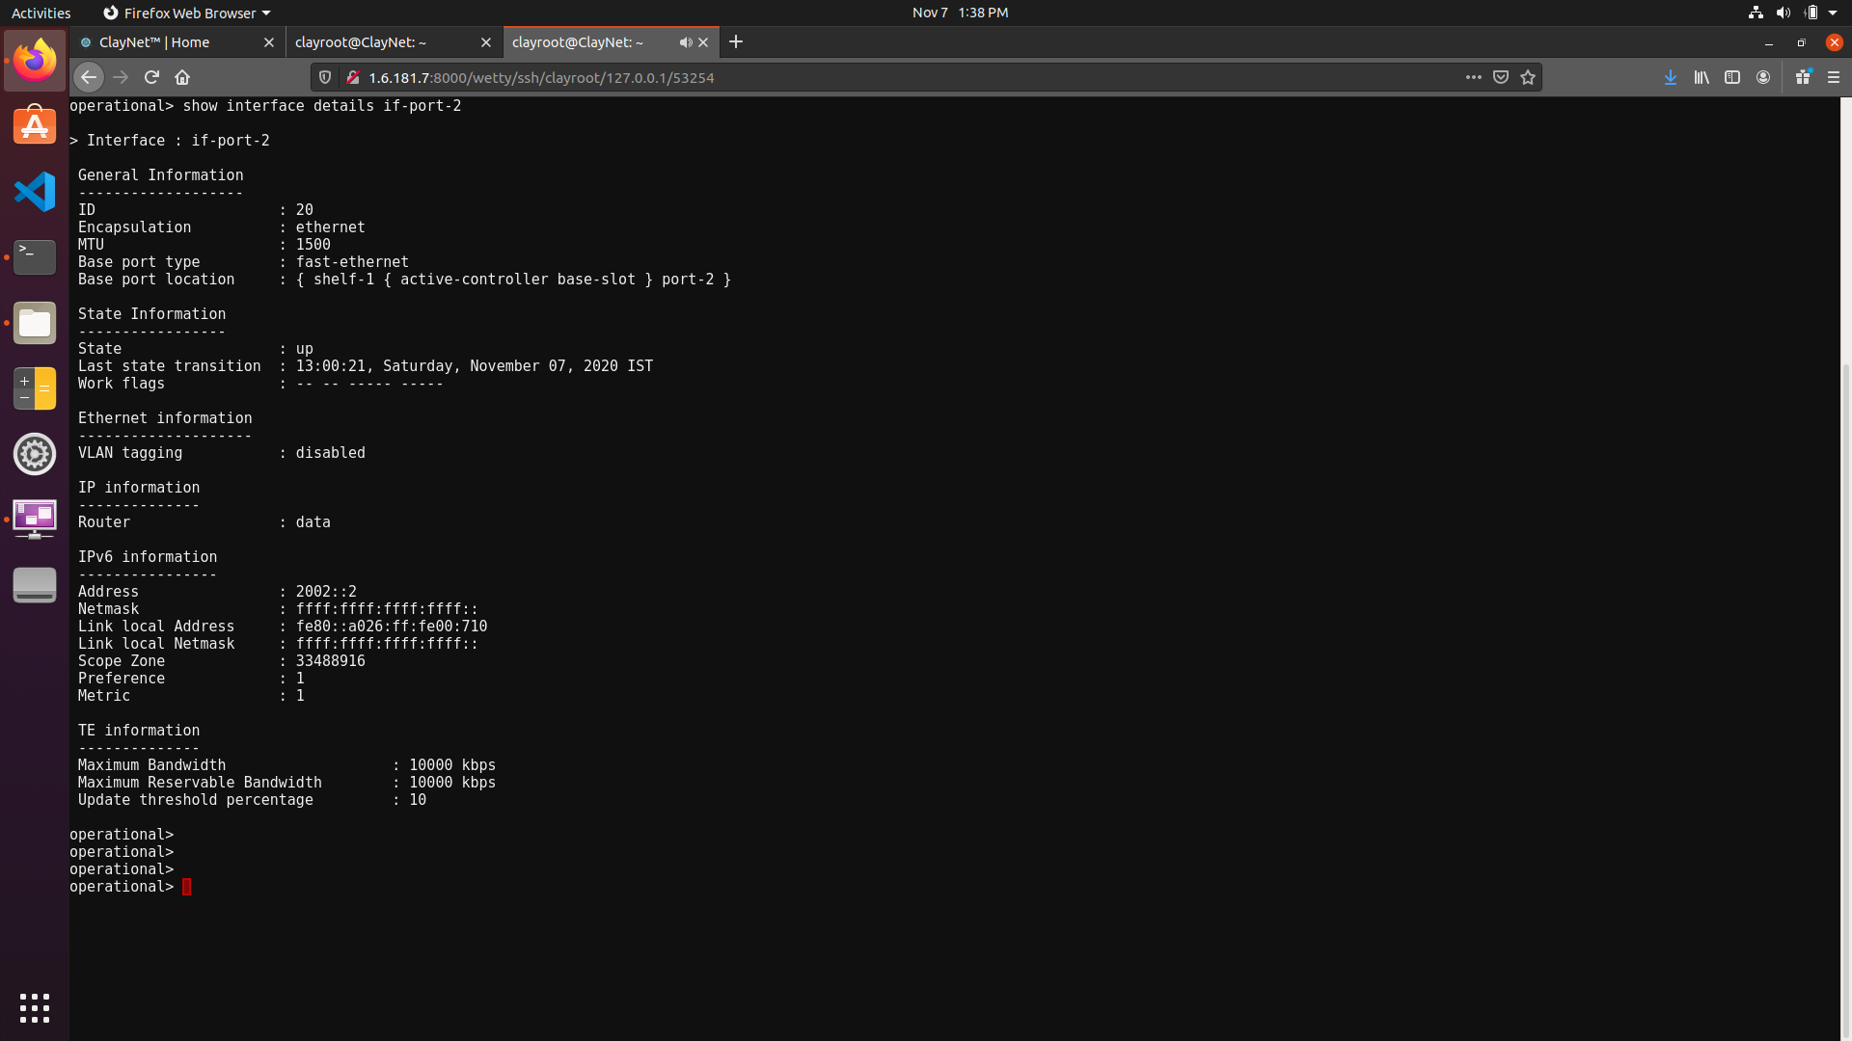

* The link-local address that was retrieved from Router2 is now used to ping the router from Router1. As shown below, there is a successful ping request made from one router to another, hence showing that the link-local and MAC addresses are consistent with each other.

